GitHub Quick and Easy

Thank you Ben Heil for teaching the CodeLouisville front-end-wed-may-2020 class your GitHub mastery!

Login to GitHub

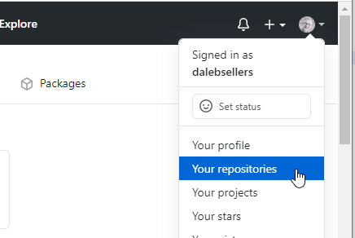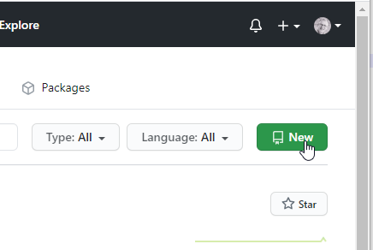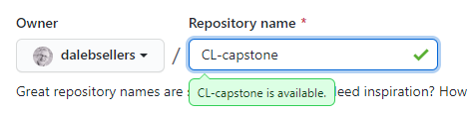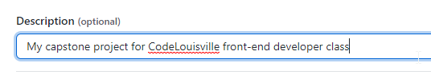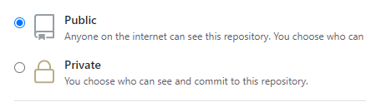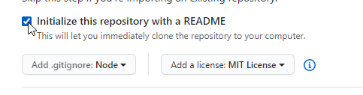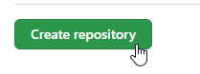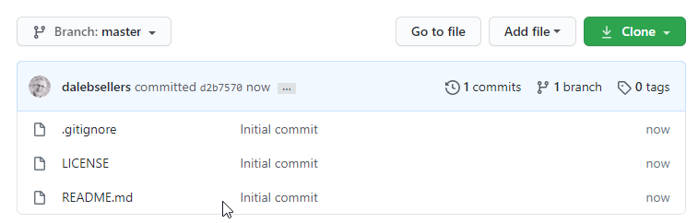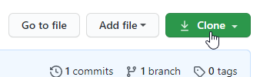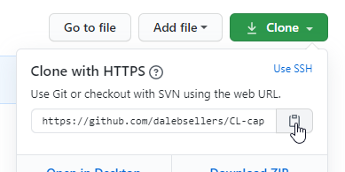

Open Visual Studio Code

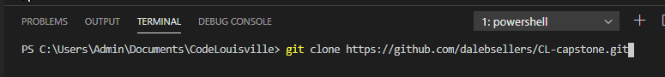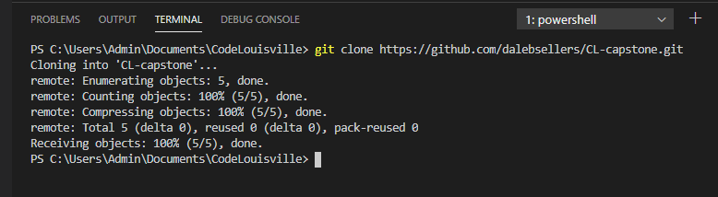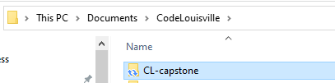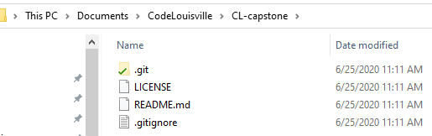

SUCCESS! new repository created on your local hard drive!

Let’s make some changes and push them up to GitHub…

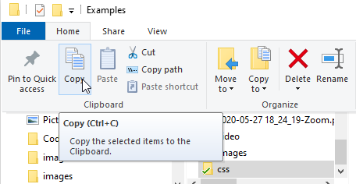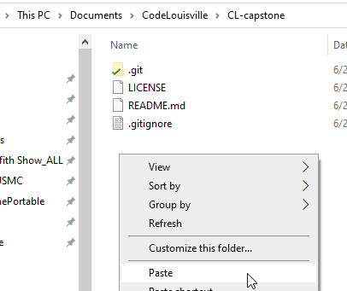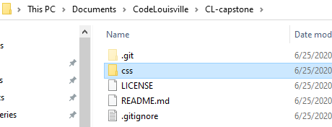

New folder and files were just added to the repository on your local hard drive…

Let’s go back to our terminal to push our changes up to GitHub…

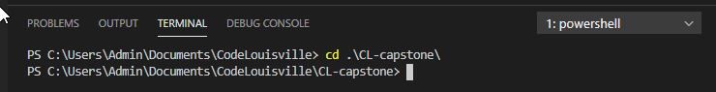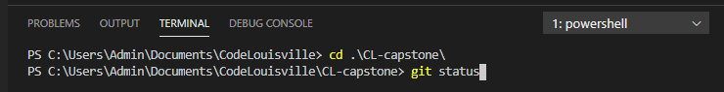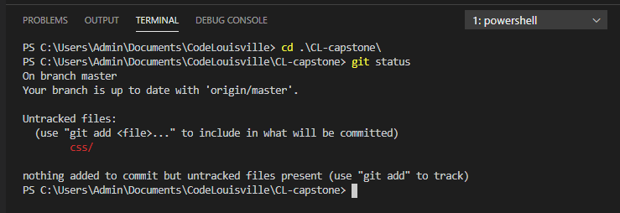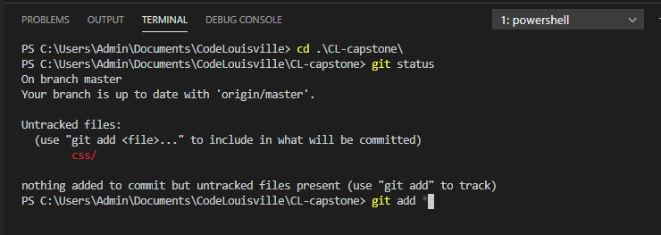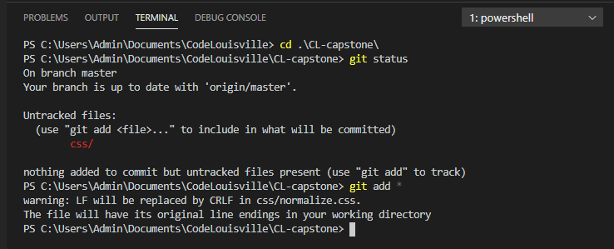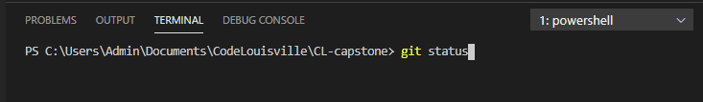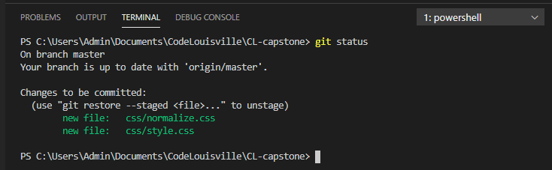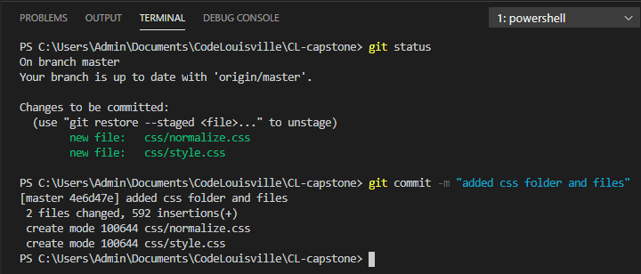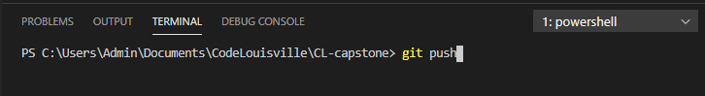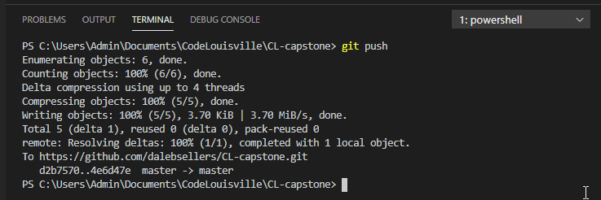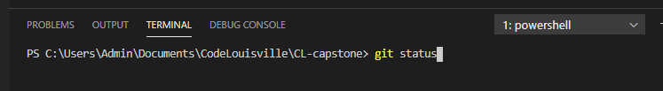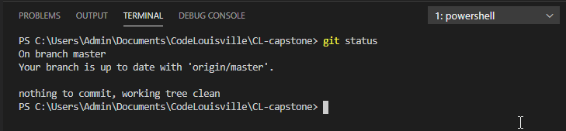

Go back to your browser to check…

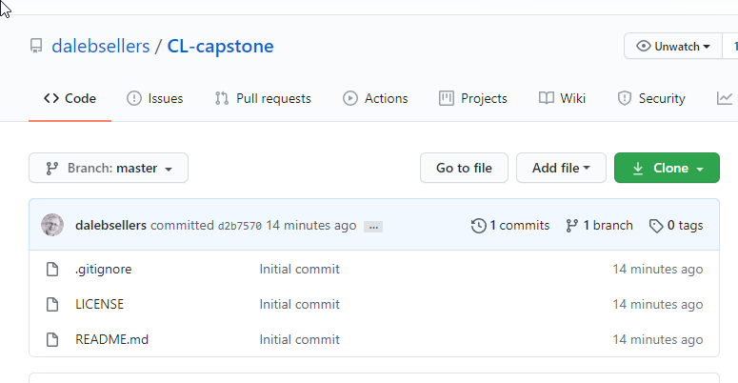

Reload/Refresh page…

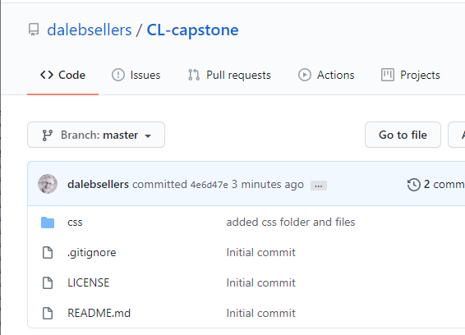

SUCCESS! Changes were pushed up to GitHub (added css folder and files).